Table of Contents

**Ladies Car Wash Application 2018** 1

Link: 1

Layout Explanation 2

Java Class Explanation 8

# **Ladies Car Wash Application 2018**

## Layout Explanation

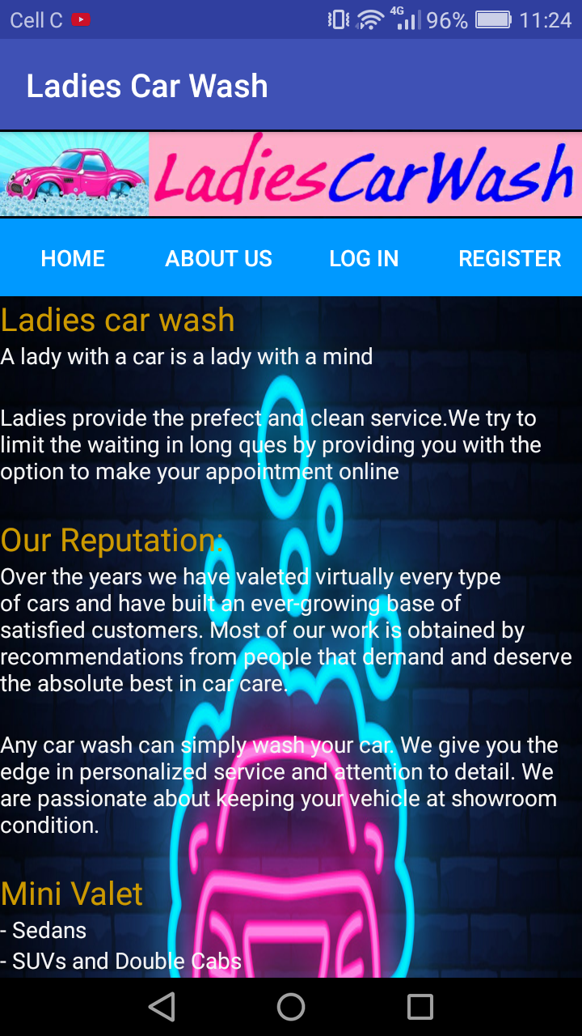 ***Figure 1***

This layout has an image view, 4 button acting as a “menu” and text views displaying the information you see on **Figure 1**.

When pressing the home button you will see **Figure 1**.

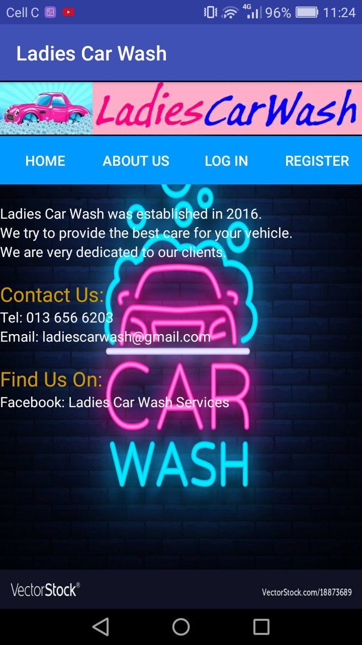 ***Figure 2***

This layout has an image view, 4 button acting as a “menu” and text views displaying the information you see on **Figure 2**.

When pressing the about us button you will see **Figure 2**.

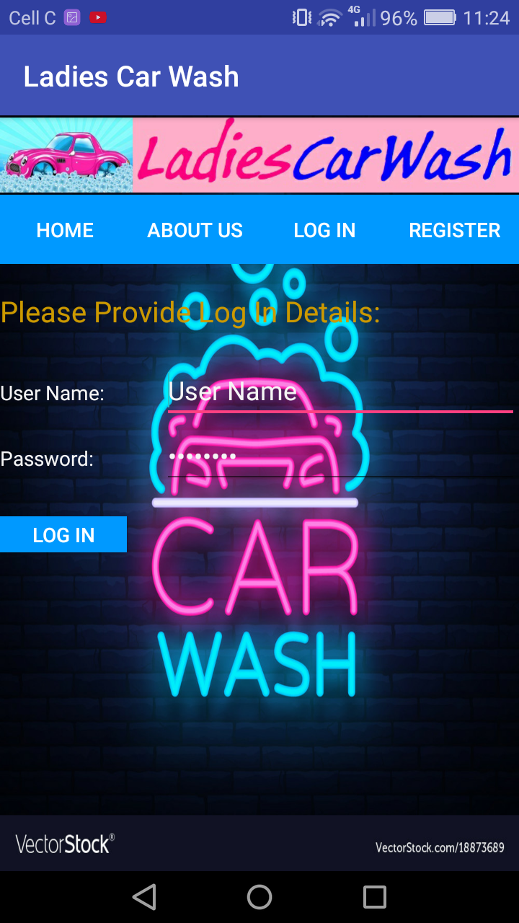 ***Figure 3***

This layout has an image view, 4 button acting as a “menu”, text views displaying the information you see on **Figure 3** and also edit texts where information can be entered on to login.

When pressing the log in button on top you will see **Figure 3**.

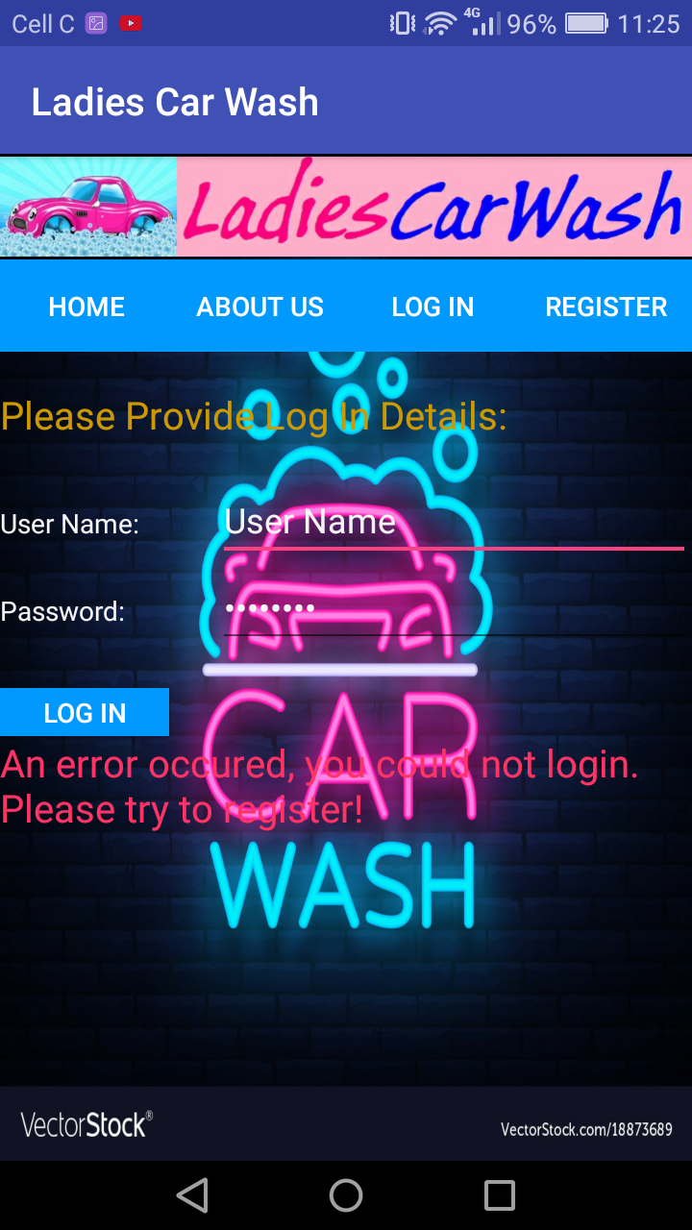 ***Figure 4***

When you have entered the log in details and you have not registered yet you will see the message displayed on **Figure 4**: “*An error occurred, you could not login. Please try to register!”*

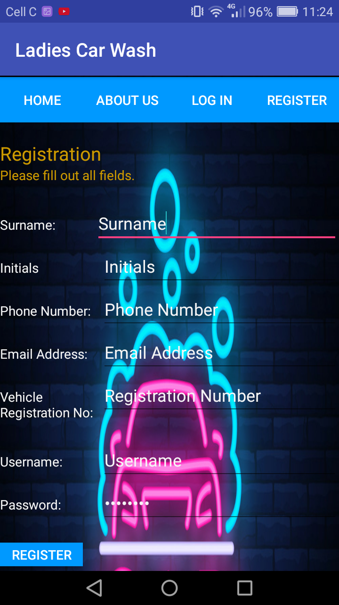 ***Figure 5***

This layout has an image view, 4 button acting as a “menu”, text views displaying the information you see on **Figure 5** and also edit texts where information can be entered on to register.

When pressing the register button on top you will see **Figure 5**. A

After you pressed the register button at the bottom after entering all information you will see a message: “You have successfully registered!”

You can now login.

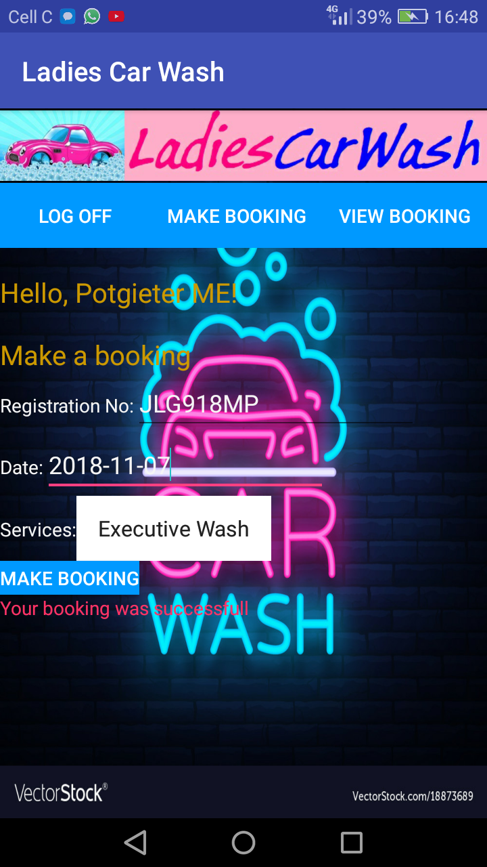 ***Figure 6***

This layout has an image view, 3 button acting as a “menu”, text views displaying the information you see on **Figure 6** and also edit texts and a drop down where information can be entered and selected to make a booking.

When pressing the “make booking” button on the menu as shown in figure 6, you’ll have to fill up your details. After entering all information, and pressed the “make booking” button at the bottom to you will see a message: “Your booking was successful”.

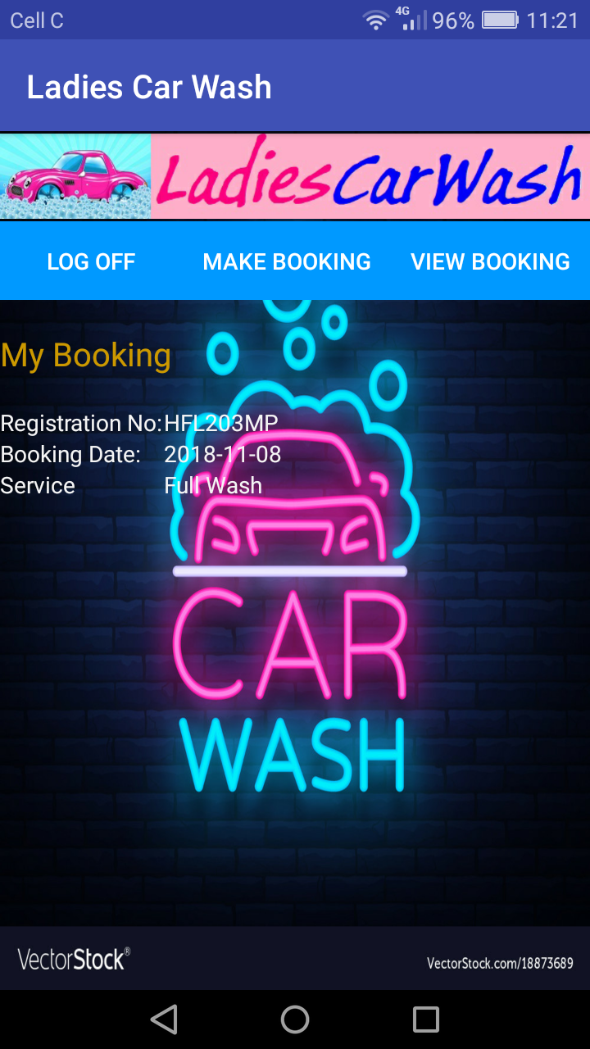 ***Figure 7***

This layout has an image view, 3 buttons acting as a “menu”, text views displaying the information you see on **Figure 7**

When pressing the “make booking” button at the bottom of **Figure 6**, the information displayed on **Figure 7** will be displayed.

## Java Class Explanation

**HomeActivity (Class)**

This class was created to display the home layout in **Figure 1.**

**AboutActivity (Class)**

This class was created to display the about us layout in **Figure 2.**

**LogInActivity (Class)**

This class was created to display the log in layout in **Figure 3** and **Figure 4.**

Also for a user to login after he/she registered.

**RegisterActivity (Class)**

This class was created to display the register layout in **Figure 5.**

Also for a user to register his/her details to make bookings and view booking and also to have login details for logging in.

**AddBookingActivity(class)**

This class was created to display the make booking layout in **Figure 6.**

**DataBaseHandler (Class)**

This class was created to handle everything associated with the database for the application. It creates the necessary tables within the database and collects the information needed from the database for processing by the application.

**Client (Class)**

This class was created to create a client object to communicate with the **DataBaseHandler Class** to create new clients (register).

**Booking (Class)**

This class was created to create a booking object to communicate with the **DataBaseHandler Class** to create bookings for registered clients.

**ViewBookingActivity(class)**

This class was created to display the viewbooking layout in **Figure 7.**

## Application Code Link

<https://github.com/mpotgieter9708/Android/blob/master/CarWashApp.zip>